Job Description

Job Title: EVI Centre Manager

Hours and location: 35 hours per week at Ebbw Vale Institute

Salary Scale: Senior Manager Scale
£30,511 - £33,000 per annum
Rising to £31,011 - £33,800 from April 2022

Holidays: 23 days per annum

Probationary period: 6 months

Length of Contract: 1 year contract (working towards a permanent position)

Responsible to: Deputy Chief Executive

ProMo-Cymru Vision: Working to ensure young people and communities are informed, engaged, connected and heard.
EVI Mission: To work with local communities and beyond to create a centre of excellence to be proud of in which people can participate in, learn, create and be entertained, in keeping with the original ethos of the Ebbw Vale Institute.

MAIN PURPOSE OF POST

- To lead and be responsible for the development and implementation of the operations of EVI with ProMo-Cymru's EVI staff and other ProMo workers.

- To be part of the Senior Management Team of ProMo-Cymru and support the strategic development of EVI and the organisation.

- To manage and deliver an EVI project recently funded by the UK Community Renewal Fund.

- To be responsible for the corporate and commercial development of the EVI.

- To develop and deliver trading and funding strategies to ensure the long-term sustainability of EVI.

- To work with the EVI and ProMo-Cymru team to further enhance the inclusive approach to the leadership and management of the Ebbw Vale Institute.

- To lead the engagement and involvement with local communities, tenants and partners.

- To line manage EVI staff.

MAIN DUTIES

The EVI Centre Manager’s role involves all of the regular duties associated with the management of a Cultural and Arts Centre, in addition to the more specific responsibilities of providing a service appropriate to the community and stakeholders.

The EVI Centre Manager will play a key role in ensuring the professional management and smooth running of EVI. Working closely with the CEO and Deputy CEO and management board as well as local and sector partners, the EVI Centre Manager will work to ensure that EVI is a vibrant, well managed, self-sufficient facility.

The post holder will need a strong commitment to helping members of the community to get involved and to help manage events at the Centre. The post holder will also need to be self-reliant, energetic, able to recognise and develop opportunities and be able to prioritise workload.

The post holder will have experience of engaging, managing and leading staff and finance management.

- To work with the staffing group to develop a stakeholder group for EVI.

- To work within the values of ProMo-Cymru.

- To ensure that all policies and procedures are followed and are appropriate with reference to best practice and senior management/HR.

- To be responsible for the smooth running of the facilities, taking appropriate action or making recommendations where appropriate.

- Liaise fully with senior management and HR in respect of day-to-day staffing and reporting.

Commercial and Marketing

- To work with the EVI team to develop the commercial and marketing strategy for the Centre and promote a positive personal and professional profile within the community. Ensuring a good reputation of the Centre at all times.

- To be sensitive to the local community needs and existing services, to assist with the full development of the Centre to help it fulfil its potential.

Financial

- To ensure that revenue opportunities for the Centre are maximised and that expenditure is controlled within budget limits. To liaise with the Finance Manager to produce reports for Management Board and to ensure the centre remains in line with any operational and business plans.

- To identify, apply and achieve new funding opportunities.

General

- Adhere to all company policies and procedures within defined timescales.

- To prepare reports for senior management and funders as required.

Health and Safety

- To ensure that all Health and Safety policies and procedures are adhered to.

- To ensure regular risk assessments are carried out and updated and that any areas of non-compliance are quickly rectified.

PERSON SPECIFICATION AND EXPERIENCE:

Requirement | Essential | Desirable | How Identified/  Assessed
Education/  Qualifications: | Recognised qualification in relevant subject (business development or management) or 3 years equivalent experience |  | Application form
Experience: | A proven track record in managing and delivering similar initiatives.  A proven track record of successful partnership working and securing funding  Experience of Marketing or Business Development and/or Management  Knowledge of Health and Safety issues and practice, including Access and Disability.  A track record of developing services  Experience of social economy sector  Experience of working in voluntary sector and partnership working  Experience of staff and team management being able to lead, motivate and manage. | Experience of managing a community or cultural centre | Application form & interview
Skills/Knowledge: | Able to use a variety of media – computer literate  Excellent customer service skills  Confident and able to work on own initiative as well as part of a team  Able to prioritise workload and demands  Able to set up and maintain operating systems and adhere to existing ones where appropriate  Understanding of financial budgeting and costing  Able to work flexible hours as centre requires | Knowledge of statutory/voluntary sector in Wales | Application form & interview
Personal Attributes: | Excellent verbal and written communication & interpersonal skills  Enthusiastic  Independent worker  Fast learner  Excellent time-management  Flexible and adaptable  Passionate about improving the lives communities in Wales |  | Interview
Other requirements: | Committed to the development of Centre services and the aims and objectives of ProMo-Cymru Ltd and the local community  Able to attend the centre at short notice  Consent to a disclosure under the Children’s Act | Driving licence with own transport.  Fluent Welsh speaker | Application form & interview

This job description may be subject to review and changed to include such duties and responsibilities as are determined in consultation with the post holder. It is not intended to be rigid or inflexible, but should be regarded as providing a framework within which the individual works .

The development of the Ebbw Vale Institute has been made possible by funding and support from:-

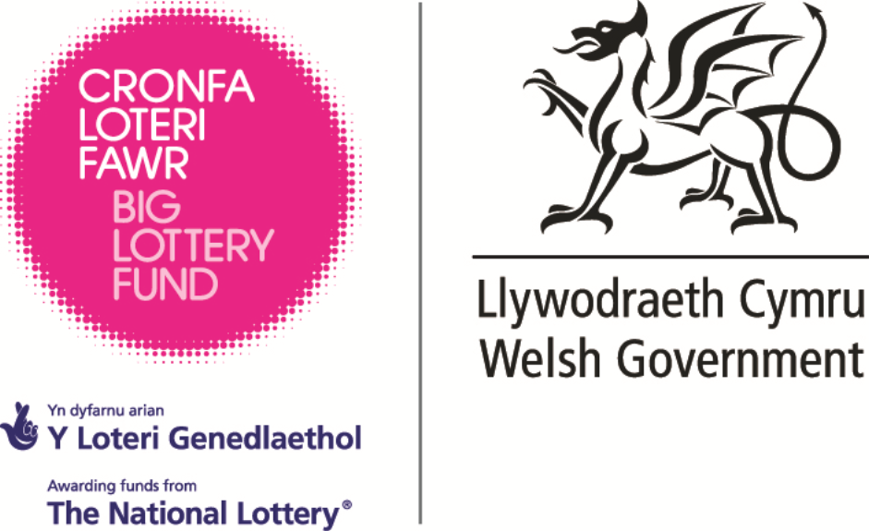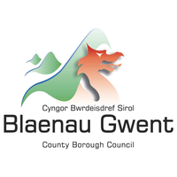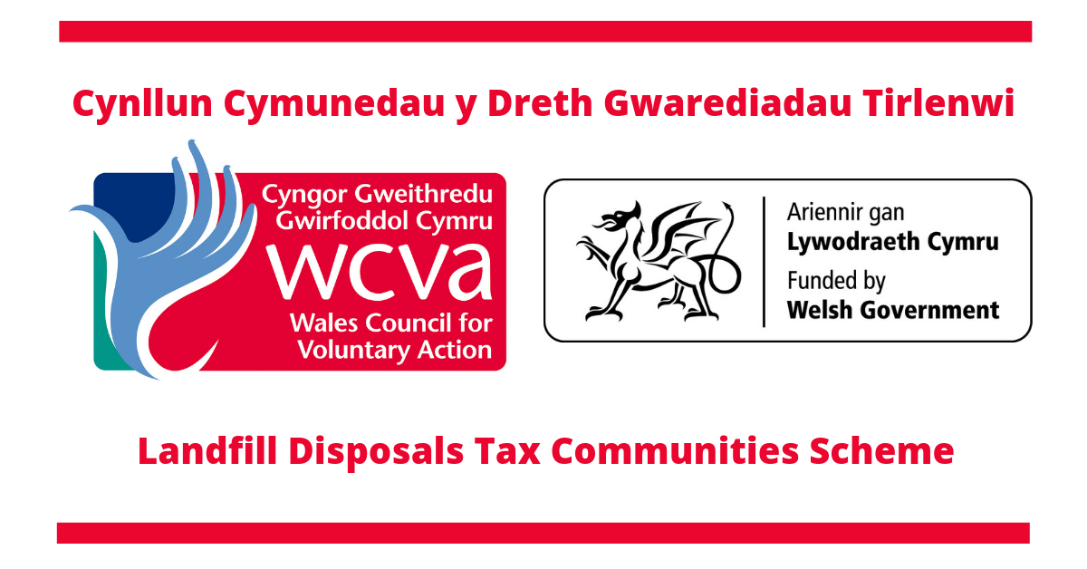
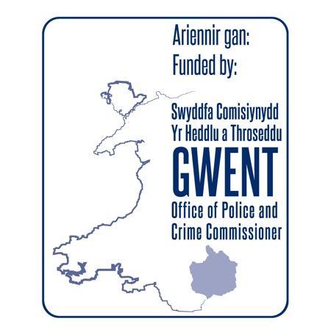

### END ###

